Nepal College of Information Technology
Assessment Fall 2015

Program : BE Elx. Time : 3 hrs
Semester : Fall FM : 100
Subject : Integrated Digital Electronics PM : 45

- Candidates are requested to give their answer as far as practicable in their own words.
- The figure in the margin indicates the full marks
- Attempt ALL question

 | - Draw RTL Exclusive-OR Gate circuit and explain its operation.  - Draw a BJT inverter and explain its operation in brief along with VTC. | 8  7
 | - Explain the operation of DTL gate with necessary circuit diagram and derivations.  - Compare and contrast DTL gate with HTL gate. | 8  7
 | - Draw the high speed TTL gate. Point out the changes made in circuit from normal TTL NAND gate. Explain their effects.  - For the TTL circuit shown below,calculate the fan-Out for driver output at logic low. Assume all the necessary parameters.  V_{BE(on)} = 0.7V V_{BE(sat)} = 0.8V  V_{D(on)} = 0.7V V_{CE(sat)} = 0.1V  β_{F} = 30 β_{R} = 0.3  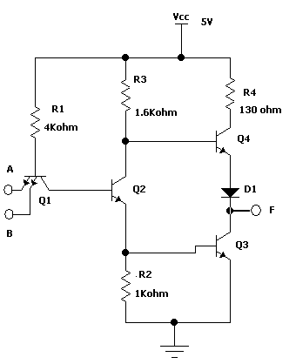 | 8  7
 | - Explain the Level translation and ECL gate interconnections with saturated logic.  - The output of the gate V_{o2} is to be fanned out to N similar gates. Find N at room temperature if the ∆1 noise margin is to be 0.3V.  Given: Rc2 = 360Ω; Re = 1.8KΩ; RE = 940Ω; VEE = -5.7V  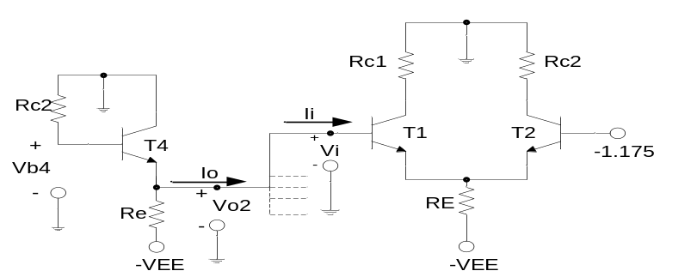 | 7  8
 | - Discuss read and write operation in static BJT Ram cell with circuit diagram  - Why CMOS is faster than PMOS and NMOS?  - Explain integrate and dump circuit operation in brief | 7  4  4
 | - Explain 6-diode transmission gate  - Draw the Voltage transfer characteristics of NMOS gate with all necessary derivations. | 7  8
 | Write short notes on (Any Two):  - 3 bit IIL decoder  - Saturated vs Non-saturated Logic families  - Current hogging problem in DCTL | 2×5

